”Stūrmaņi”, Saldus pag.,
Saldus nov.; LV - 3862 Reģ.Nr. LV48503008458
Mob tel: 371-295 77 896
info@nerolimet.lv
www.nerolimet.lv

COMMERCIAL OFFER
SIA……………………………………. Date : 01.06.2022
Automatic cylindrical sheet palletizer and depalletizer.
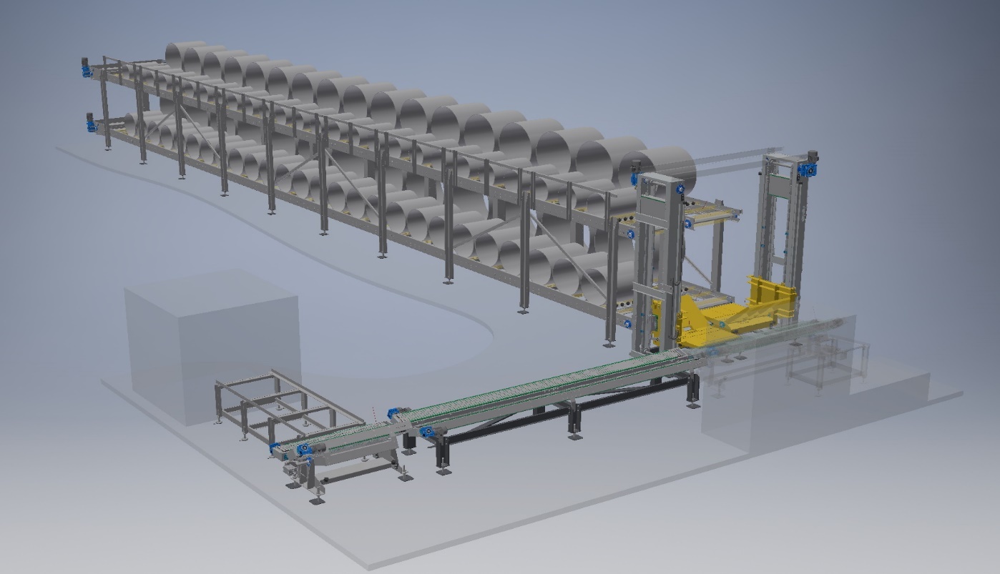
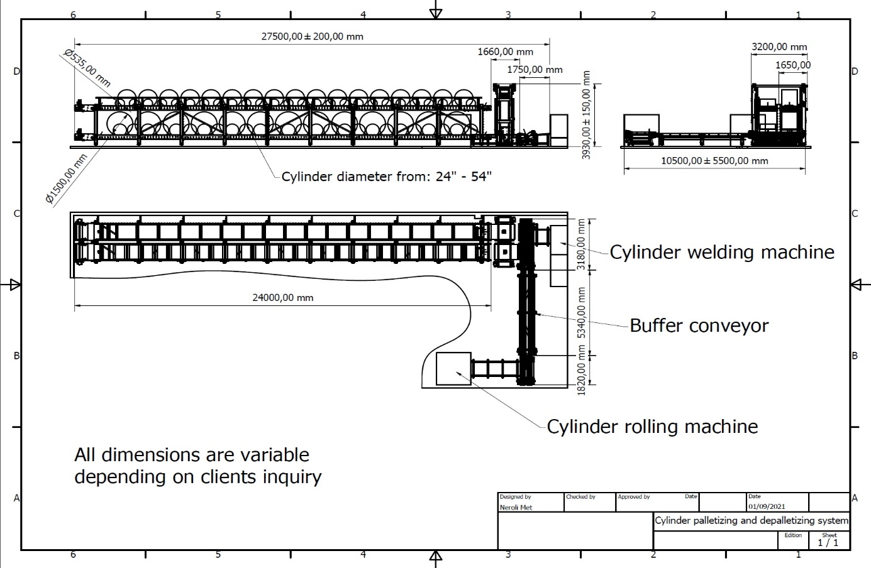

* * * Technical data * * *
Cylinder diameters: from 530mm – 1500mm (24” – 54” inch)
Weight of cylinder: up to 200 kg
System depending on configuration can store up to ~ 150 pcs.
Electrical power: 2,5 kW/h

Dokumentācija:
* CE marking and CE declaration of conformity
* Instructions for use in English
* Components with order codes
Atbilstība:
* Directive 2006/42/EC on machinery
* Directive 2014/30/EU on electromagnetic compatibility
* Directive 2014/35/EU on electrical equipment designed for use within
certain voltage limits
* Standard ISO 12100 Safety of machinery

Warranty: 12 months
Delivery time: up to eight months from the receipt of the advance payment.
Payment terms:
60% - as order confirmation;
30% - before delivery of the equipment;
10% - after running the equipment into operation;

SIA „Neroli Met”
2022. year 01. june

